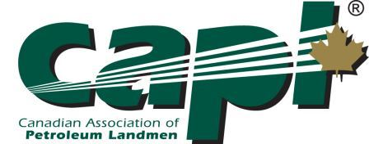
CANADIAN ASSOCIATION OF PETROLEUM LANDMEN
CML/CSL APPLICANT VERIFICATION FORM

Click here to enter text. has applied for Certification as a CML ☐ / CSL ☐ and I have been listed as one of the applicant’s sponsors.

Please complete this form in full as your verification of the applicant’s qualification to become a CML ☐ / CSL ☐.

Name: | Company: | Designation:
Click here to enter text. | Click here to enter text. | P.Land® ☐ PSL® ☐  Land Agent Lic # Click here to enter text.  CPL ☐ RPL ☐  None ☐
Address: | Phone/Fax: | Email:
Click here to enter text. | Click here to enter text. | Click here to enter text.
Known Applicant for (# of years) | Relationship to Applicant
Click here to enter text. | Click here to enter text.

- Based on your personal knowledge, please describe in detail the applicant’s work experience. This should include the full extent of types of work and the approximate years or months involved.

Click here to enter text.

- Please describe the applicant’s professional expertise and ethical conduct.

Click here to enter text.

- Please make any comments you feel pertinent to the committee’s decision.

Click here to enter text.

In my opinion, the applicant meets or exceeds the professional and ethical standards for a CML ☐ / CSL ☐ designation.

Date Signature
Name: Click here to enter text.

